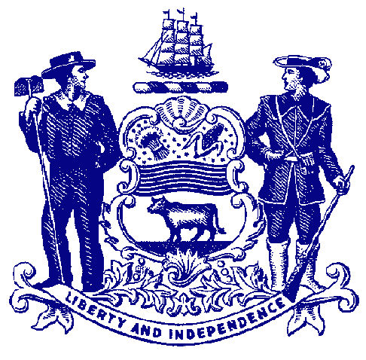

Delaware House of Representatives
Rep. John Kowalko

For Immediate Release:
January 27, 2022

Rep. Kowalko Announces Retirement from General Assembly

Newark legislator will leave House at end of term after 16 years in office

DOVER – On Thursday, Rep. John Kowalko announced that he will retire from the House of Representatives at the end of his term this fall. First elected in 2006, Rep. Kowalko represents Newark and areas just south of the city.

Below is a statement Rep. Kowalko read on the House floor today:

“I have had the privilege and pleasure of serving as a State Representative for almost 16 years.

“As you all might know, this is my second career. For 37 years, I was a machinist. I was a proud union member during that time, serving as a union official and advocate. I worked at the Delaware City refinery for 25 years serving as union steward and General Foreman. These experiences gave me a solid foundation for Rules of Order and their importance, the power of solidarity, and a profound respect for the working men and women and their families.

“I have held these values which are so dear to me throughout my career as a legislator. I am proud of my continuous and resolute support for not only organized labor but for all working people and their families, and for all of Delaware’s citizens. My bills, and the bills I put my name on support ordinary people, working people, parents, children, the homeless, and Delaware’s small business community. I have always supported government transparency, good government, and open government. I have always supported and sponsored bills improving healthcare, voting rights, gender equity, and the environment.

“I have met some amazing people through the years and have been honored by the rust people placed in me, ranging from neighbors on my street to being featured in French news media regarding transparency and corporate giveaways. I was privileged to be one of four U.S. legislators invited to England, at the British government’s expense, for a series of discussions with government officials that included visits to offshore wind sites and universities that had training programs for engineers and craftsmen dedicated to offshore wind technology. I was humbled and honored to share a mutually respected friendship with former Governor Russell Peterson, truly one of the most accomplished and environmental advocates in Delaware. Being a legislator has been awe-inspiring and humbling and I’m proud of the fact that I have remained a full-time legislator, never using my position in Dover to augment my career and income.

“When I was first elected Democrats were in the basement. We were a distinct minority party. I have been there and I am proud that Democrats hold a significant majority today. I was a founding member of PDD (Progressive Dems for Democrats) and I am especially proud of my work for the progressive movement, furthering its ideals, and encouraging, mentoring, and supporting progressive candidates for offices all over the state and country. Many of you are in these halls with me today.

“I am announcing my retirement at the end of this term. There is a time for everyone to pass the baton and this term is my time. I am counting on my fellow progressives to continue my efforts.

“I will work hard for my constituents for these last nine months and in November I will pass my position as the 25th district representative over to a new, and hopefully just as progressive person.

“Thank you.”

###

