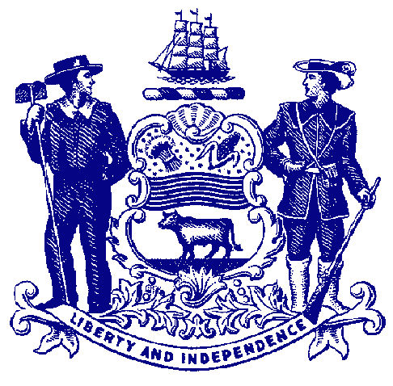

Delaware House of Representatives
Rep. Larry Mitchell

For Immediate Release:
June 16, 2022

House Passes Bill to Prohibit Large-Capacity Firearm Magazines

SB 6(S) would limit capacity of magazines to 17 rounds

DOVER – Continuing the General Assembly’s efforts to address gun safety issues, the House passed a measure Thursday that would prohibit the sale of large-capacity gun magazines in Delaware.

Sponsored by House Majority Whip Larry Mitchell, Senate Bill 6(S) would outlaw the sale of large-capacity magazines capable of holding any more than 17 rounds, set elevated penalties for the use of illegal magazines in the commission of a crime and create a buyback program to purchase large-capacity magazines currently in circulation.

The measure is part of a historic six-bill package announced earlier this month in the wake of multiple mass shootings last month. Taken together, the bills would raise the age from 18 to 21 to purchase most firearms, prohibit the sale and manufacture of assault-style weapons, strengthen background checks, hold gun manufacturers and dealers liable for reckless or negligent actions, and ban the use of devices that convert handguns into fully automatic weapons.

“There is no logical reason for the average person to be able to fire 20, 30 or 100 bullets without the need to reload. Limiting the number of rounds a person can fire at once is another piece of the puzzle to reduce gun violence without impacting a person’s right to own or use a firearm,” said Rep. Mitchell, D-Elsmere. “As a retired police officer, I’ve seen firsthand how gun violence can tear apart families and the dangerous implications of large-capacity magazines. What we’re doing today is taking a meaningful step toward addressing the ongoing and tragic issue of gun violence, and I’m looking forward to seeing this bill signed into law.”

Large-capacity magazines have been used in all 10 of the deadliest mass shootings over the last decade, while mass shootings that involved large-capacity magazines have resulted in twice as many fatalities as those that do not, according to the Giffords Law Center to Prevent Gun Violence.

A 2018 study also found that as many as 36% of guns used in crimes and nearly 40% of guns used to commit serious violent crimes – including the murder of law enforcement officers – were equipped with large-capacity magazines. At least nine states and the District of Columbia have enacted laws banning large-capacity magazines, including New York, New Jersey, and Maryland – all of which set their cap on magazine capacity at 10 rounds.

“This bill has endured quite the odyssey on its way to passage and I want to thank my colleagues in the House for working to reach a consensus,” said Senate President Pro Tempore David Sokola, the bill’s lead sponsor. “Limiting the sale of these large-capacity magazines in Delaware will likewise help to save lives in police standoffs and mass shootings in our neighborhoods. It may have taken a few more votes than any of us expected but outlawing these dangerous devices was worth the effort.”

The measure heads to the Senate for final consideration.

###

