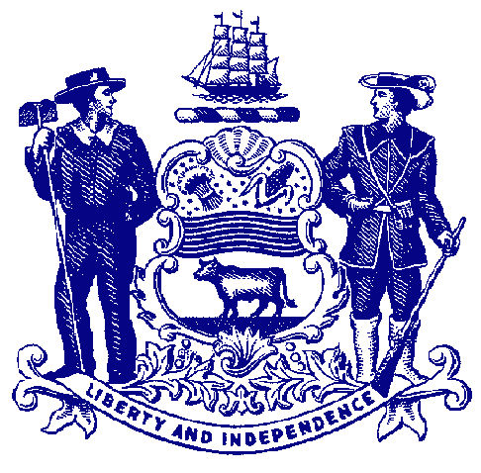

Delaware House of Representatives
Rep. Ed Osienski

For Immediate Release:
May 5, 2022

House Passes Osienski Bill Legalizing Adult Possession of Marijuana

HB 371 would remove all penalties for possession of one ounce or less of marijuana
for those 21 and older.

DOVER – The House passed legislation Thursday that would remove penalties for the adult possession of small amounts of marijuana, paving the way for legal adult recreational marijuana.

Sponsored by Rep. Ed Osienski, House Bill 371 would remove all penalties for possession of one ounce or less of marijuana, except for those who are under 21 years of age. Possession of more than one ounce of marijuana and public consumption remain unclassified misdemeanors.

Under current state law, the possession of one ounce or less of marijuana by a person 21 years of age and older carries a civil penalty of $100. That provision would be eliminated under HB 371. Possession, use or consumption of recreational marijuana by anyone under 21 would still result in a civil penalty.

“During this very involved process, we have heard from numerous members of the public – advocates, veterans, retired law enforcement officers, educators and even faith leaders – who have overwhelmingly voiced support for legalizing adult recreational marijuana,” said Rep. Osienski, D-Brookside. “Delaware is more than capable of successfully enacting policies for safe and legal cannabis. I’m grateful to the House for passing this bill and look forward to continuing this effort until Delaware is poised to establish a new, legal industry in our state.”

HB 371 is part of a two-pronged effort to legalize and regulate adult recreational marijuana in Delaware. Previous attempts to pass one bill legalizing adult recreational marijuana and regulating the cultivation, sale and possession of marijuana have fallen short in the House of Representatives, prompting Rep. Osienski to separate the two main components of the effort.

Regulating the legal industry of growing and selling cannabis would require a three-fifths (3/5) majority vote in each chamber, and previous measures attempting to legalize and regulate marijuana have fallen short. However, because HB 371 does not have any taxation or revenue aspect to it, the measure only requires a simple majority, or 21 votes in the House. HB 371 passed Thursday 26-14.

“This is a historic day for the State of Delaware and Delawareans across our state who, for years, have overwhelmingly supported the legalization of marijuana,” said Sen. Trey Paradee, D-Dover, the bill’s lead Senate sponsor. “Today, my colleagues in the House achieved what many naysayers believed was impossible just a few years ago. I want to thank my colleagues in the House for passing legislation to finally rid ourselves of the penalties that have long been unjustly and inequitably applied to people of color, and taking what I hope will be another major step toward replacing the illegal marijuana market with a thriving industry that will create good-paying jobs for the residents of our state. I am fully committed to quickly passing House Bill 371 in the Senate and sending this groundbreaking legislation on to Governor Carney for his signature.”

A companion bill, House Bill 372, has cleared a House committee and could be acted upon in the House in the coming weeks. That bill would create a legal framework to regulate the cultivation, sale and possession of marijuana, and provide opportunities for small businesses to be licensed. HB 372 would require a 3/5 vote in each chamber (25 in the House).

Neither bill would not change existing state law regarding driving under the influence of an illicit or recreational drug. They also would not allow individuals to grow their own plants. Public consumption of marijuana would still not be permitted.

Employer enforcement largely would not change. Employers would be permitted to drug test workers for marijuana to ensure any zero-tolerance policies are being followed. They also would be able to discipline workers for being under the influence at work, as well as prohibit the consumption of marijuana at work.

Currently, recreational marijuana use is permitted in 18 states and the District of Columbia. Nearby states New Jersey, Virginia and New York have legalized adult recreational cannabis.

HB 371 heads to the Senate for consideration.

###

