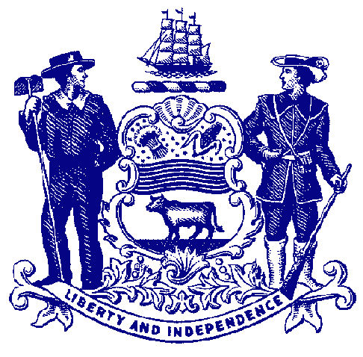

Delaware House of Representatives
Rep. Ed Osienski

For Immediate Release:
May 24, 2022

Rep. Osienski Issues Statement on House Bill 371

HB 371 would remove penalties for adult possession of small amounts of marijuana

NEWARK – Rep. Ed Osienski issued a statement Tuesday regarding House Bill 371, which would remove penalties for the adult possession of small amounts of marijuana.

HB 371 would essentially legalize the adult possession of one ounce or less of marijuana, paving the way for adult recreational marijuana. The General Assembly passed the bill by strong, bipartisan majorities earlier this month. Governor Carney announced on Tuesday he was vetoing the measure:

“More than 60% of Delawareans support the legalization of marijuana for adult recreational use. Earlier this month, more than 60% of the General Assembly voted in favor of ending the prohibition against possession of a personal use quantity of marijuana.

“Unfortunately, the governor has chosen to ignore the will of residents and a bipartisan super-majority of the General Assembly by vetoing HB 371. I’m deeply disappointed in his decision, especially since he could have allowed the bill to become law without his signature, which would have preserved both his personal opposition and the will of the residents and legislators. I will review what options are available and decide on any next steps at a later time.

“Vetoing HB 371 will not stop people from obtaining and consuming marijuana. It simply means they could face civil penalties for possession. We have to look no further than New Jersey to see how a new industry can create jobs and generate revenue – sales reached nearly $2 million on its first day. Until we establish a similar market in Delaware, people will continue to obtain marijuana illegally here through the illicit market or send tax revenue across the Delaware Memorial Bridge to New Jersey.”

###

