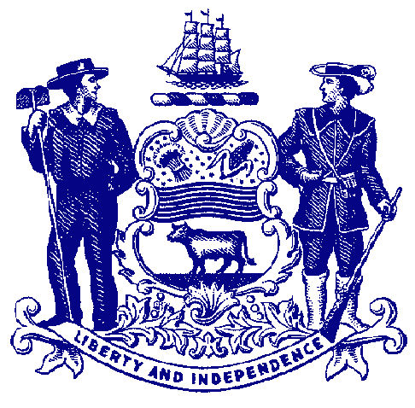

Delaware House of Representatives
Rep. Ed Osienski

For Immediate Release:
May 23, 2022

Lawmakers, Officials, Advocates Announce Agreement to Aid Deaf and Hard-of-Hearing Community’s Movie-Going Experience

Memorandum of understanding between advocacy groups. legislator and theater owners
ensure majority of movie theaters will offer open captioning

WILMINGTON – Lawmakers, advocates and Delaware movie theater operators announced an agreement on Monday that will increase access for individuals who are deaf or hard-of-hearing at theaters throughout the state.

The memorandum of understanding outlines a year-long pilot program involving theaters in all three counties. The locations will offer regular showings of first-run movies using open captions on the screen. Open captions are always in view on the screen during a movie or program. The program began officially on April 1.

In 2014, the exhibition industry entered into an agreement with leading national deaf and hard of hearing advocacy groups to ensure closed captioning devices were available at every theatre in the United States. However, some moviegoers prefer their films presented with open captions rather than using the devices.

Daphne Werner, a language arts teacher at the Delaware School for the Deaf, brought her concerns to Rep. Ed Osienski, whose district includes the school. They convened a group of advocates and representatives from the National Association of Theatre Owners. Several theaters throughout the state already offered showings with open captions, so they sought to formalize these showings, ensure they are marketed properly and to collect data about usage.

“When this issue was brought to my attention by my constituent, Ms. Werner, I knew this was something that we in Delaware could pull together effectively. We have the opportunity as a small state to make sure that every resident in the state has access to open captions at a nearby movie theater,” said Rep. Osienski. “I’m proud of the work we put in to reach this agreement and improve the moviegoing experience for residents throughout Delaware. It’s not just the deaf and hard-of-hearing community that will benefit – many other residents will enjoy having open captions available. I’m especially happy that we are collecting information and coming together to re-evaluate the program so we can discuss and make improvements as necessary.”

Under the MOU, participating theaters detailed their offerings of first-run movies with open captions. For example, Cinemark Theatres is offering one open captioning show per day of a film in its first two weeks of release. Penn Cinemas has dedicated one auditorium to playing open captioned films at every showtime, every day. Milford Movies will show three open captioned movies per new title each week with one Saturday matinee, and weekday matinee shows on Mondays and Wednesdays.

“Open captions benefit everyone, hearing loss or no, whether it’s deaf and hard-of-hearing residents, children, English language learners, individuals with learning disabilities, or people who prefer captions to more easily understand dialogue,” said Ms. Werner. “Open captions are a cheaper alternative for theaters than purchasing and maintaining hundreds of individual-use closed captioning devices, and bear less risk of user error. We must continue breaking down barriers and create a more universally accessible moviegoing experience. We need to that dispel the notion that individuals with disabilities – and therefore their needs – are ‘less than’ those able-bodied individuals and their needs or preferences.”

During the pilot program, NATO members will collect data on the impact on theater operations for open captioned shows and share that data with interested parties. NATO will also request anonymized customer feedback data be shared as part of the data collection.

“We are thrilled to have more open caption shows all over the state, where it does not only impact deaf and hard-of-hearing people, but it will be used by other groups of people who enjoy the open caption shows. We thank Daphne Werner for speaking up for the DHH people. We thank Rep. Osienski and the NATO members for listening to us, especially with the small population of DHH in Delaware, and piloting the efforts to have more open caption shows in the next year,” said Mindi Failing, Delaware Statewide Programs coordinator for the Deaf and Hard of Hearing.

“I personally attended an open caption show in Rehoboth Beach recently and I encourage you to attend the open caption shows throughout the state to support our NATO members and movie theatres. This is one of many efforts to support the inclusion for all people with and without disabilities to participate in every aspect of life to the fullest as possible. Again, thank you for making the movie shows more inclusive for us.”

As part of the arrangement, NATO members will clearly display which showtimes offer open captioning in each of their theaters when patrons purchase a ticket on a theater’s website or at the box office.

“The exhibition industry remains committed to providing a positive experience to all moviegoers, and the pilot programs running in Delaware will offer additional options for those patrons who would like to see a movie with open captions,” said John Fithian, President and CEO of the National Association of Theatre Owners. “We look forward to continuing our productive dialogue with the state and stakeholders to help our members best serve the communities they operate in.”

After the year-long pilot has concluded, Rep. Osienski, NATO, Delaware exhibitors, and other interested parties will reconvene to discuss the data gathered during the pilot period, solicit feedback from advocates, and discuss the future of these plans. NATO also will host quarterly check-in calls with Rep. Osienski and others to solicit feedback on the programs and provide updates.

“The State Council for Persons with Disabilities (SCPD) truly appreciates the efforts of all those involved in making open captioning in movie theaters an option that is available for individuals who are Deaf and Hard of Hearing in Delaware,” said Kyle Hodges, policy director for the State Council. “SCPDs mission, in part, is to advocate for services which empower persons with disabilities to be fully integrated into the community. Providing open captioning will allow persons who are Deaf and Hard of Hearing and their families the opportunity to participate and enjoy going to the movies just like everyone else. It is another effort to protect the civil rights for individuals with disabilities, which is truly the intent of the Americans with Disabilities Act.’

###

